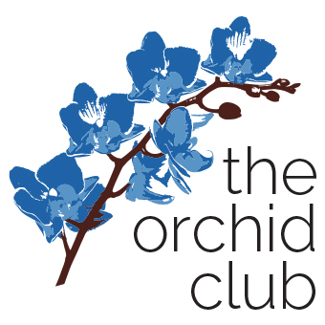
Sunday | Monday | Tuesday | Wednesday | Thursday | Friday | Saturday
 |  |  |  | 1 | 2 | 3
Parent Support Group 10-11:30
The Commons
4 | 5 | 6 | 7 | 8 | 9 | 10
Parents’ Day Out, 2-5 pm  YMCA |  | Fitness Class  1:30-2:30  YMCA |  |  |  | Wellness Workshop, 3-4:30  Bozeman Library
11 | 12 | 13 | 14 | 15 | 16 | 17
18 | 19 | 20 | 21 | 22 | 23 | 24
Fitness Class
1:30-2:30
YMCA
25 | 26 | 27 | 28 | 29 | 30 | 31
 |  |  |  |  | *

March 2018
Calendar of Events
The Commons at Baxter & Love:  1794 Baxter Lane  Bozeman  YMCA:  3673 Love Lane  Bozeman | More information at www.facebook.com/theorchidclubmt  www.orchidclubmt.org  Parents private group: www.facebook.com/groups/theorchidclub/ | The vision of the Orchid Club is that every family raising a child with special needs will feel supported, empowered, and connected with others sharing the joys and struggles of this unique journey. Through play groups, community events and educational opportunities, the goal of the Orchid Club is that you know you are not alone and there is joy to be found.

